Lesson 5 Demo 2
Integrate Git with Jenkins
Objective: Integrate Git with Jenkins

Tools required: Git and Jenkins

Prerequisites: You need to have jenkins installed in order to proceed with this demo. If you don’t have jenkins installed please refer to demo 1 of lesson 5.

Steps to be followed:
- Install Git plugin

Step 1: Installing Git plugin
  - Open the browser, and go to Jenkins dashboard by typing localhost:8080 in your browser.

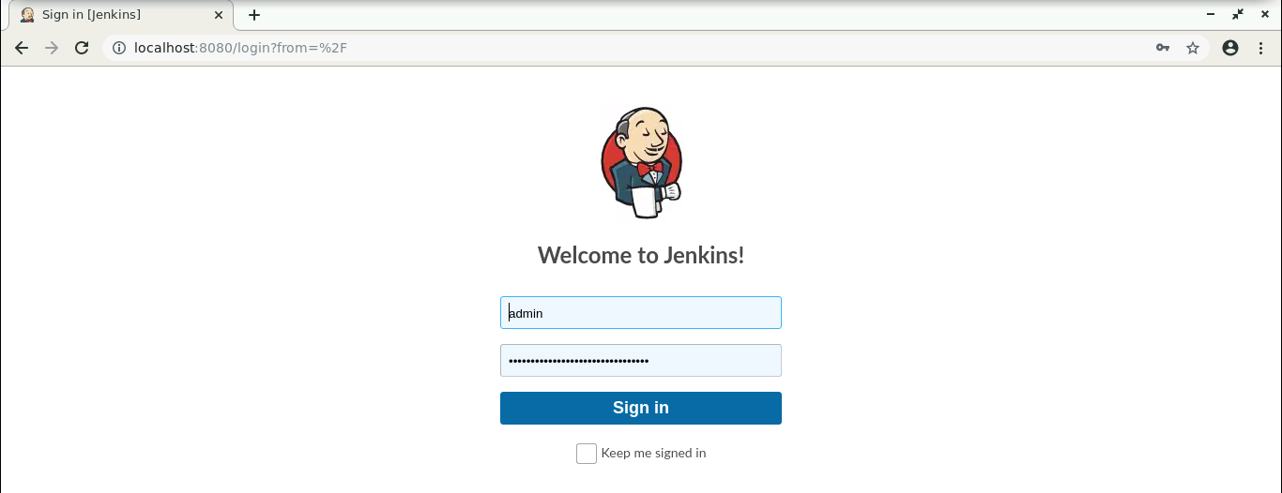

  - Provide the credentials, and click on Sign in.

1.3 Click on Manage Jenkins. From the list of options, choose Manage Plugins.
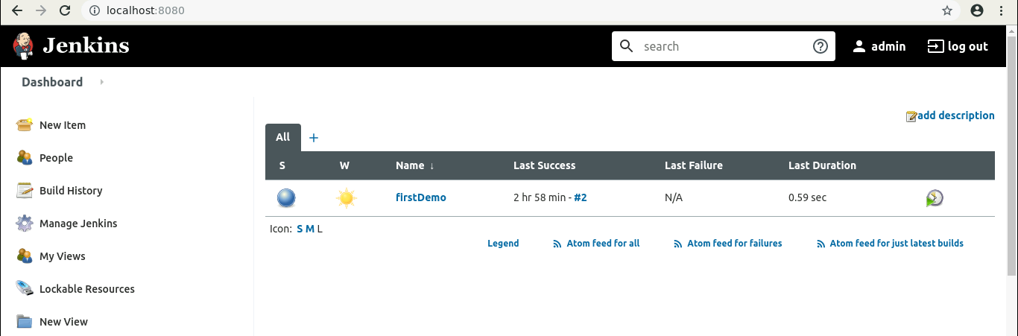

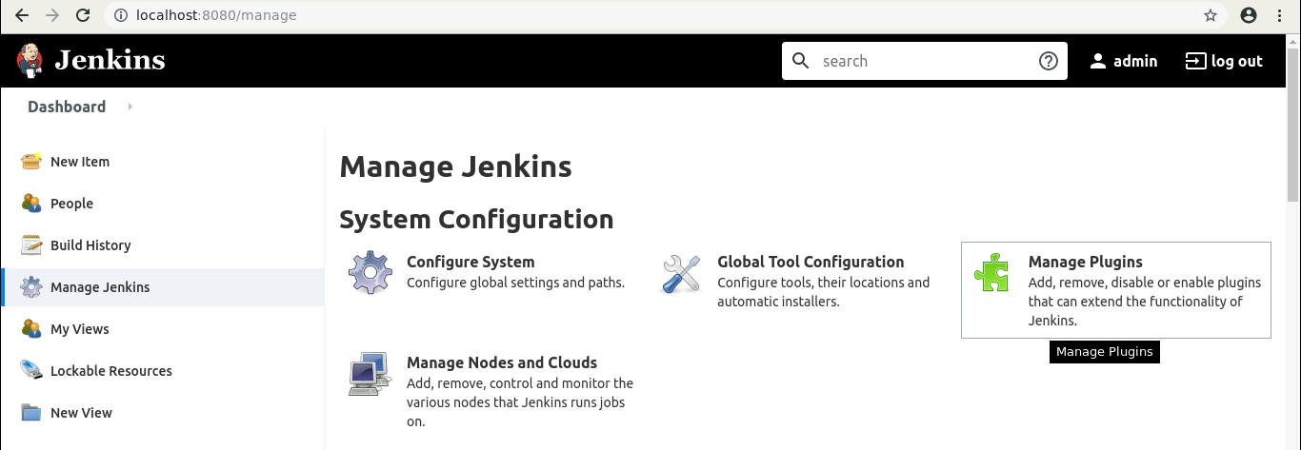

  - Under the Available tab, select Git Plugin.

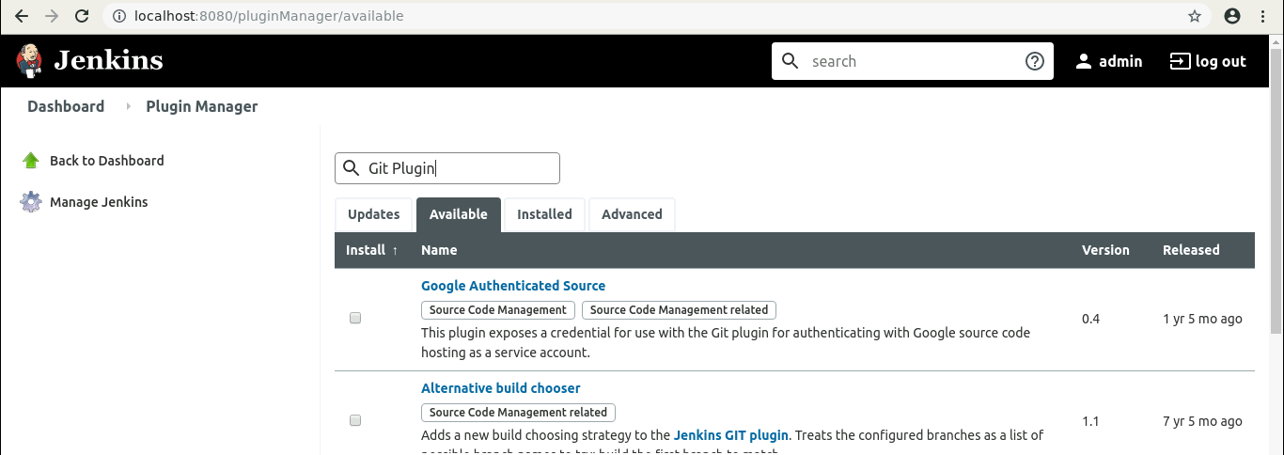

  - Click on Install without restart, and the plugin will be installed.

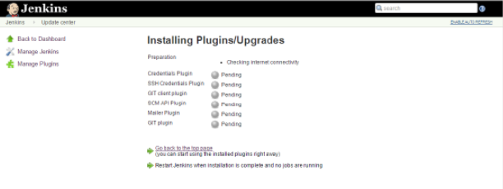

  - To verify whether the plugin is installed, go to Dashboard, click on Manage Jenkins, select Manage Plugins, go to Installed tab, and search for Git plugin.

